**Lady Freda of the Mansions**

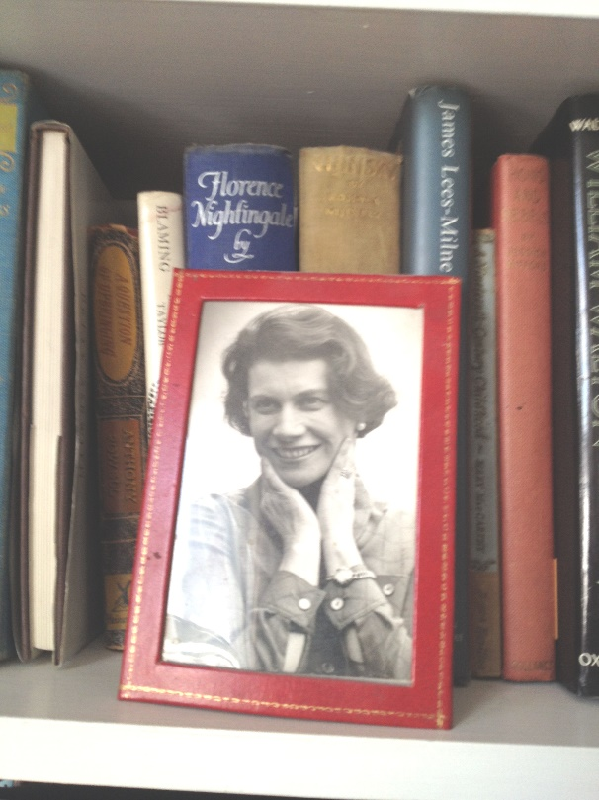Many years ago, more than I care to remember, we visited our dear friends, Bob Annibale & Edésio Fernandes, at the famous Hereford Mansions, in West London. Bob had moved to the Mansions.

A notable & well known resident was Lady Freda Berkeley, one of the star residents at ‘the Mansions’.

This photo was displayed in her sitting room & was of Freda in her salad days - as she would say!

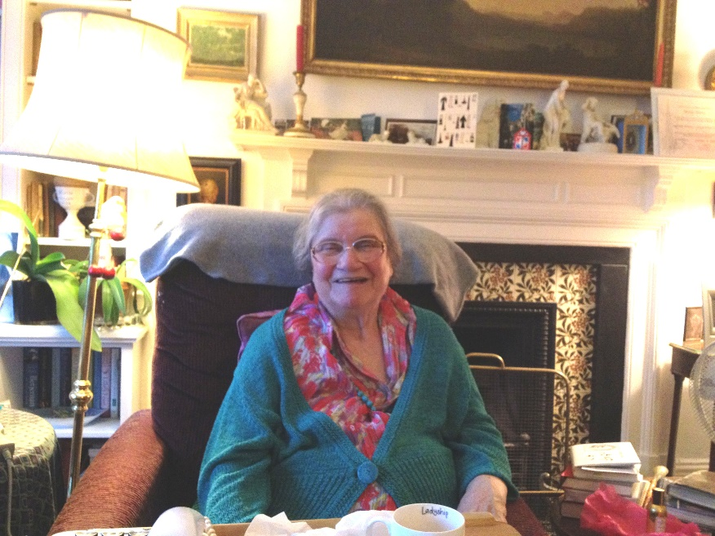

Freda’s elegant sitting room was where she received guests. She immensely enjoyed her friends & visitors.

Her carer & friend Erica took care of her & attended to her needs. Freda adored fine foods & an occasional tipple.

What was thrilling was to listen to the stories Freda told. They were about her life & those of other people. She was always generous & never catty.  She was also always exciting to be with!

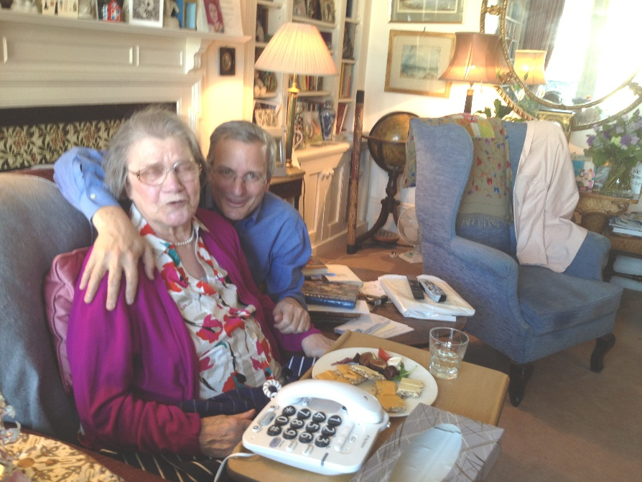

When Bob met Freda they became instant friends. And then a little while later, great friends with  Edésio. She simply adored them!

Both men were warm & affectionate  & that suited Freda well. She was a warm & open person. She enjoyed talking to them about her family & was very proud of her children.

Both Bob & Edésio provided immense support for her.

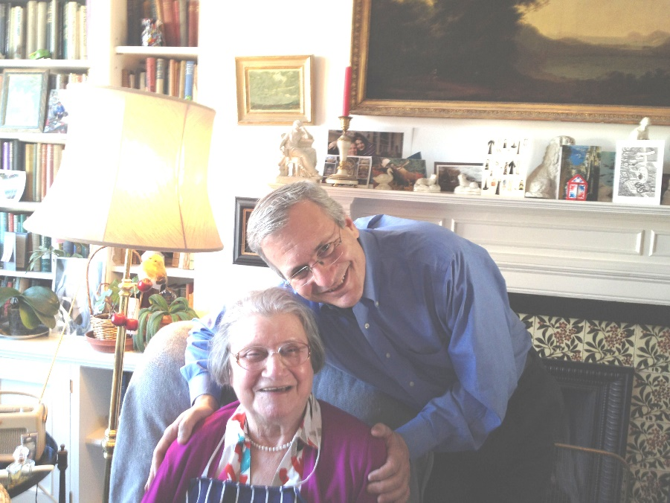Bob & Edesio were regular visitors & saw Freda on a regular basis. They enjoyed talking about everything, not least the art works which Freda had in her home. Freda often talked about her home with Lennox & her children in Warwick Avenue in Little Venice, London.

The brilliant book written by Tony Scotland in 2010,[***Lennox & Freda***](https://www.lennoxberkeley.org.uk/biography_by_tony_scotland.php), is a veritable treasure trove of information.

To read more on the life of this amazing woman that’s definitely the book to read.

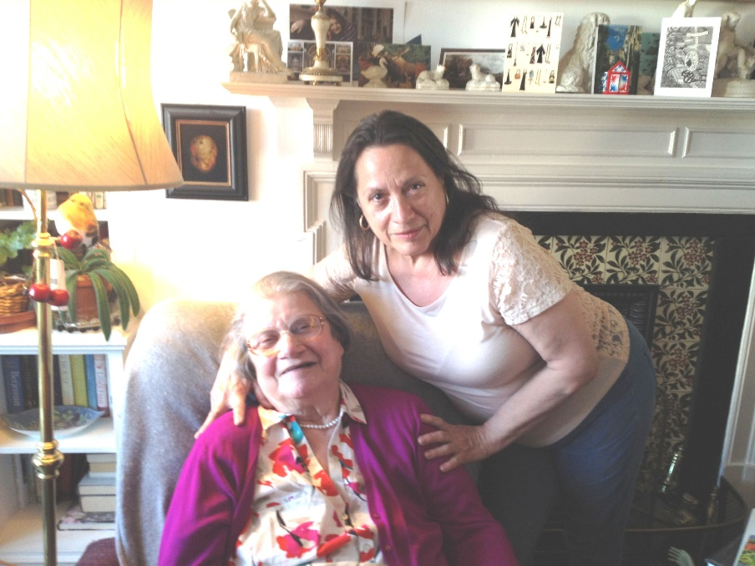I absolutely adored visiting Freda. You always learnt something from her. It was always like being in the presence of history. You were in the presence of fascinating social history.

But it was the joy with which she told her stories which was riveting. Freda had a joie de vivre & exuberance which was infectious.

You always left her feeling happy. I miss her very much. Her spirit lives on.

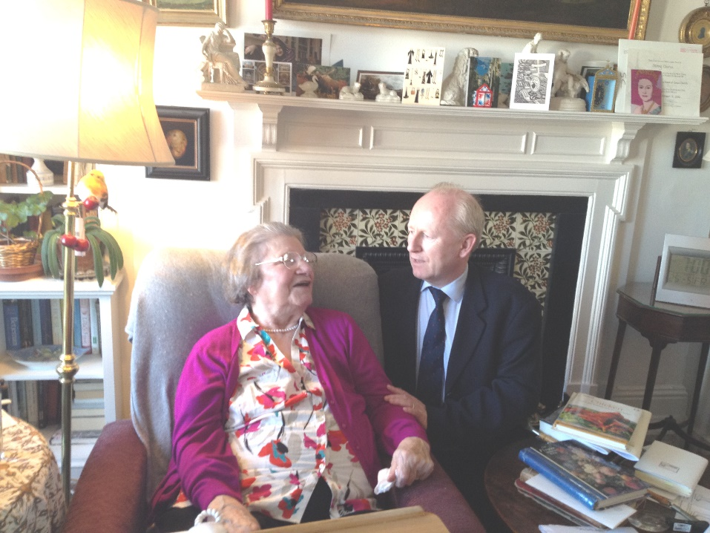Robert, my husband, loved visiting Freda. Freda also loved having him over. The calmness of his voice soothed her.

Freda enjoyed calmness & it seemed to allow her to ruminate on her past & connect up to memories of the recent past as well as earlier events.

Whatever pain Freda may also have felt, happiness was always in the foreground of her long & rich life.

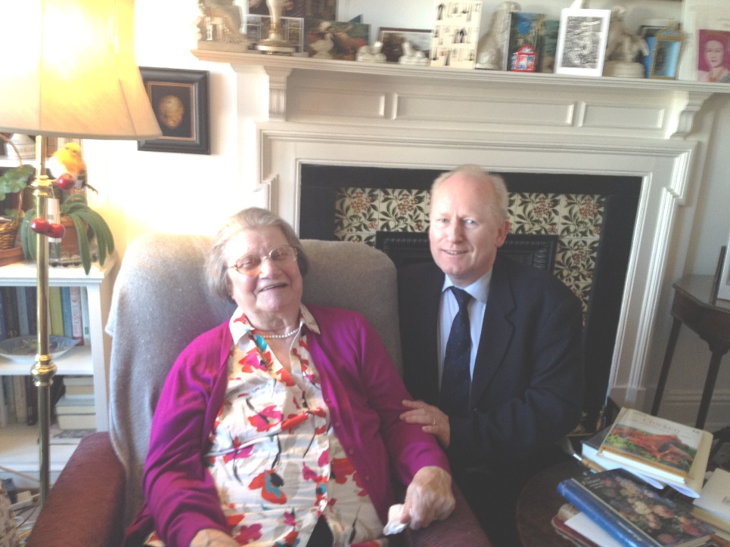It is very difficult to find any photo of Freda where she is not smiling. That is why people who knew her have loving memories of her. We cherish the memory of her happiest times while at the Mansions.

It was a privilege to know this remarkable lady, Our Freda of the Mansions, Lady Freda Berkeley. We cherish her memory & miss her.

We raise a glass to her. She is in our hearts. Eternal memory. God bless Lady Freda Berkeley!